Newsletter
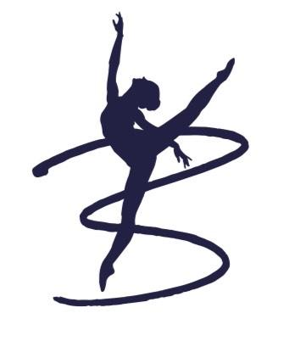
July 2022
Mrs Nicholsons’ Message
As my first year as Principal it has certainly been a whirl wind and a year to never forget, from examinations, Student Night, our Bi-Annual Show, Summer Fairs and of course having baby Bonnie. I couldn’t have achieved this year without the support of the Bingham School of Dance family, so I sincerely say Thank You.
New Uniform and Dancewear Shop:
Bingham School of Dance have a new uniform starting September. This can be seen on our website. We will have a physical shop on site ran by Shan and Alison.
We do understand the impact cost of living currently has, we do not expect any student to buy new uniform until they have outgrown their old and have tried our best to keep cost of uniform low.
A further expectation from September is that each student has their hair tied back from Grade 1, an attempt at a bun would be brilliant where and when possible.
Initial Uniform Shop Dates
- Saturday the 3rd of September 2.00-5.00pm
- Thursday the 8th of September 4.00-6.30pm
- Thursday the 22nd of September 4.00-6.30pm

Charity Success
We successfully raised £4038.67 for Lincs and Notts Air Ambulance. Which is an amazing amount. Thank you to everyone who helped to support this amazing cause.

Term Dates
- Saturday 3rd September to Saturday 15th October (inclusive)

- HT: Monday 17th October to Saturday 29th October 2021

- Monday 31st October 2022 to Friday 9th December 2022 (inclusive)

- Proposed (not confirmed) Examination Dates 10th &11th of December 2022

Availability for Sept classes
- Nursery Ballet aged 3+ (Wednesday)
- Junior Modern (Saturday)

Celebration of Success
Congratulations to Hermione Cumbers for successfully auditioning for Nottingham Arts Theatre production of West Side Story.
Congratulations to Esme Amoabil and Harriet Tyreman for successfully auditioning for English Youth Ballet in their production of Sleeping Beauty.

Final Note
If you havent already please follow Bingham School of Dance on the following:
Facebook:
Bingham School of Dance
Groups: Bingham School of Dance Parent Group (Private Group)
Instagram:
Binghamschoolofdance.co.uk (Private Group)
Here we share a plethora of information which allows you to gain insight into upcoming events etc.

