Newsletter
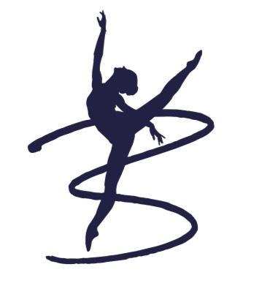
December 2022
Bingham Shop:
If you wish to order uniform you can email them directly at myduetorders@gmail.com
There will be physical shops, dates will be confirmed via facebook or email.
Celebration of Success
Congratulations Harriet Lees for successfully auditioning for Nottingham Musical Theatre Assosciates.
Well done Ava Murray (Newark Palace Theatre) and Hermione Cumbers ( Nottingham Arts Theatre) for successfully auditioning for Pantomimes.
Eloise Warriner (L4) and Ava Murray (L3) recently applied and successfully gained places at BBO for Level 4 Teaching Diploma and Level 3 Dance Teaching Assistant Courses.

Key Message
I have added an extra Saturday on the 1st of April to make up for the loss of the Saturday for the Kings Coronation in May.
Examinations
We have recently had examinations, results for these can take up to three months to be delivered, please move up to the next class in January.do not wait for the results.
Term Dates
- Saturday 7th January 2023 to Saturday the 1st of April 2023 inclusive
- Half Term: Monday 13th Feb to Saturday 25th Feb 2023 inclusive
January Preparation
Invoices have now been shared via paper copy, please email me if you have not received one. Please pay prior to the start of term.
Bingham School of Dance
Account Number: 41846968
Sort Code: 309090
New email account contact:
binghamschoolofdance@gmail.com
Telephone: 07792583158
Availability for January
- Nursery Ballet age 3+ (Wednesday)
- Nursery Ballet age 3+ (Saturday)
- Junior Modern (Saturday)
- Performing Arts Junior 5+ (Tuesday)

